技術翻訳専門講座 化学コース（和訳） サンプル課題

次の英文を和訳し、MS-Word形式ファイルで事務局答案係に提出してください。なお、図面内で翻訳が必要と思われる語は対訳形式で記載してください。

課題１
Element
A chemical element is a pure substance which is composed of a single type of atom, characterized by its particular number of protons in the nuclei of its atoms, known as the atomic number and represented by the symbol Z. The mass number is the sum of the number of protons and neutrons in a nucleus. Although all the nuclei of all atoms belonging to one element will have the same atomic number, they may not necessarily have the same mass number; atoms of an element which have different mass numbers are known as isotopes. For example, all atoms with 6 protons in their nuclei are atoms of the chemical element carbon, but atoms of carbon may have mass numbers of 12 or 13.[53]
The standard presentation of the chemical elements is in the periodic table, which orders elements by atomic number. The periodic table is arranged in groups, or columns, and periods, or rows. The periodic table is useful in identifying periodic trends.[54]
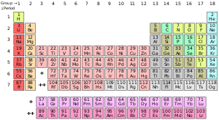
Standard form of the periodic table of chemical elements. The colors represent different categories of elements

（出典元：https://en.wikipedia.org/wiki/Chemistry）

